Allen Taylor

CMIS 350 6382

Project 2

2/4/2022

**UML Diagram for Project 2**

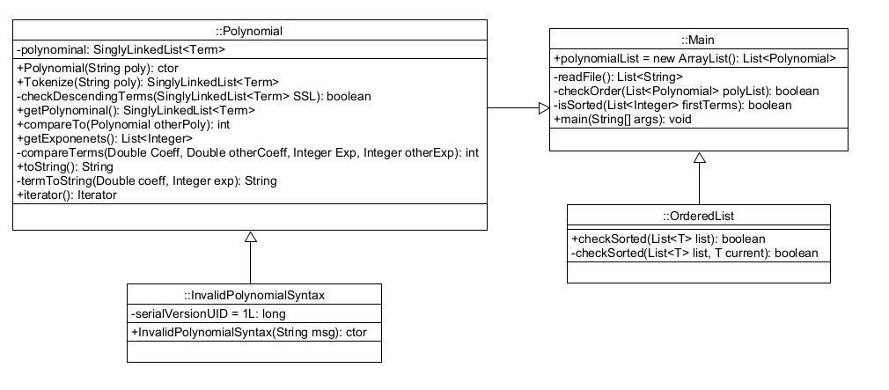

**Test Case 1**

Requirements:

1. Test cases include a file in both strong and weak sorted order.
2. Test cases include a polynomial with exponents of 0, 1 and 2 or more.

|  |  |
| --- | --- |
| Input: | 4.0 2 2.5 1 8.0 0  4.5 4 5.0 0 5.0 0  5.0 4 5.7 2 8.6 0 |
| Expected Output: | Strong Ordered: true  Weak Ordered: true |
| Actual Output: | Strong Ordered: true  Weak Ordered: true |

**Test Case 2**

Requirement:

1. Test cases include a file in weak but not strong sorted order.
2. Test cases include a polynomial with exponents of 0, 1 and 2 or more.

|  |  |
| --- | --- |
| Input: | 4.0 2 2.5 1 8.0 0  5.0 4 5.0 1 0 0  4.5 4 5.7 1 8.6 0 |
| Expected Output: | Strong Ordered: false  Weak Ordered: true |
| Actual Output: | Strong Ordered: false  Weak Ordered: true |

**Test Case 3**

Requirement:

Test cases include a file in neither strong nor weak sorted order

|  |  |
| --- | --- |
| Input: | 4.5 4 5.0 0 5.0 0  4.0 2 2.5 1 8.0 0  5.0 4 5.7 2 8.6 0 |
| Expected Output: | Strong Ordered: false  Weak Ordered: false |
| Actual Output: | Strong Ordered: false  Weak Ordered: false |

**Test Case 4**

Requirement:

InvalidPolynomialSyntax thrown by the constructor of the Polynomial class when:

1. The supplied string contains coefficients or exponents of an improper type.
2. Exponents fail to be listed in strictly descending order.

|  |  |
| --- | --- |
| Input: | -1 1 8.0 0 4.0 2  5.0 4 5.0 1 0 0  4.5 4 5.7 1 8.6 0  2.5 1 8.0 0 4.0 2  5.0 4 5.0 1 0 0  4.5 4 5.7 1 8.6 0 |
| Expected Output: | JOptionPanes display error messages. |
| Actual Output: | JOptionPanes display error messages. |

**Lessons Learned**

One of the hardest parts of this assignment was using the Comparable Interface. I finally found a solution in the provides coding examples in the Week 1 Generics. This provided me with the isSorted method.

To determine the Weak Order of a list of Polynomials I did the following:

1. Read all exponents from the Polynomial.
2. Take only the exponent from the FIRST term.
3. Do this for all Polynomials in the list and add them to a List<Integer>.
4. Lastly, use the isSorted to check if they are in Weak Order.